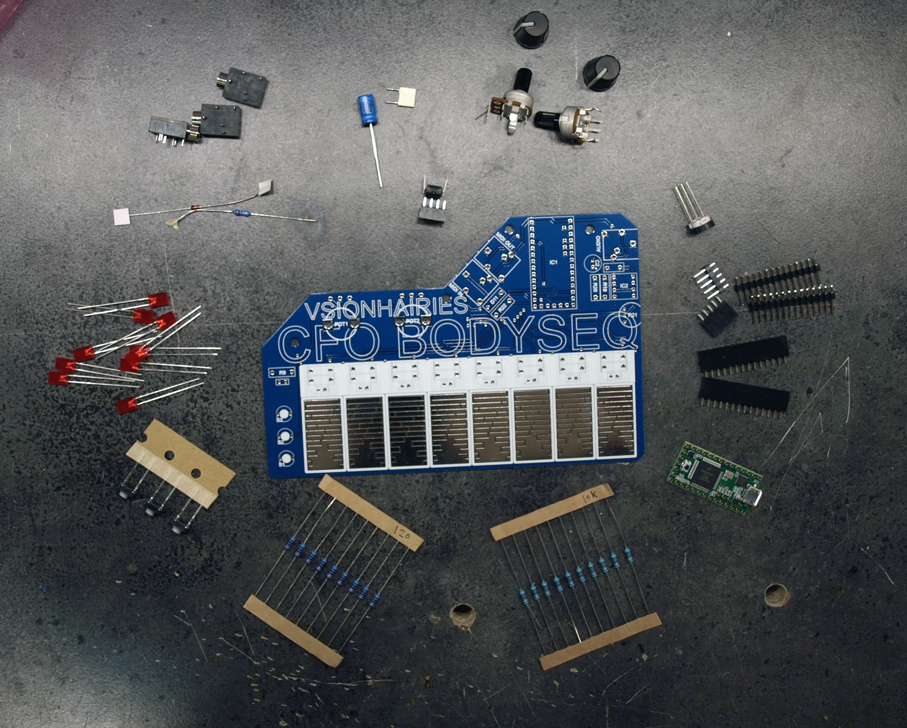

check that you have all parts (refer to BOM – bill of materials)

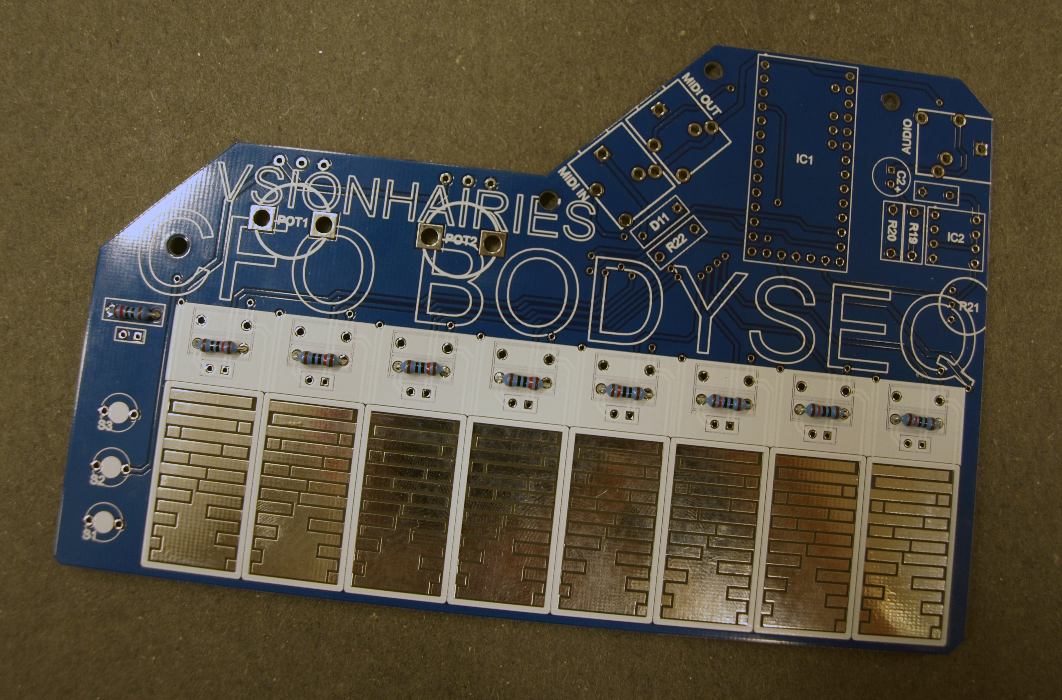

solder LED resistors R1 – R9 (120 ohm)

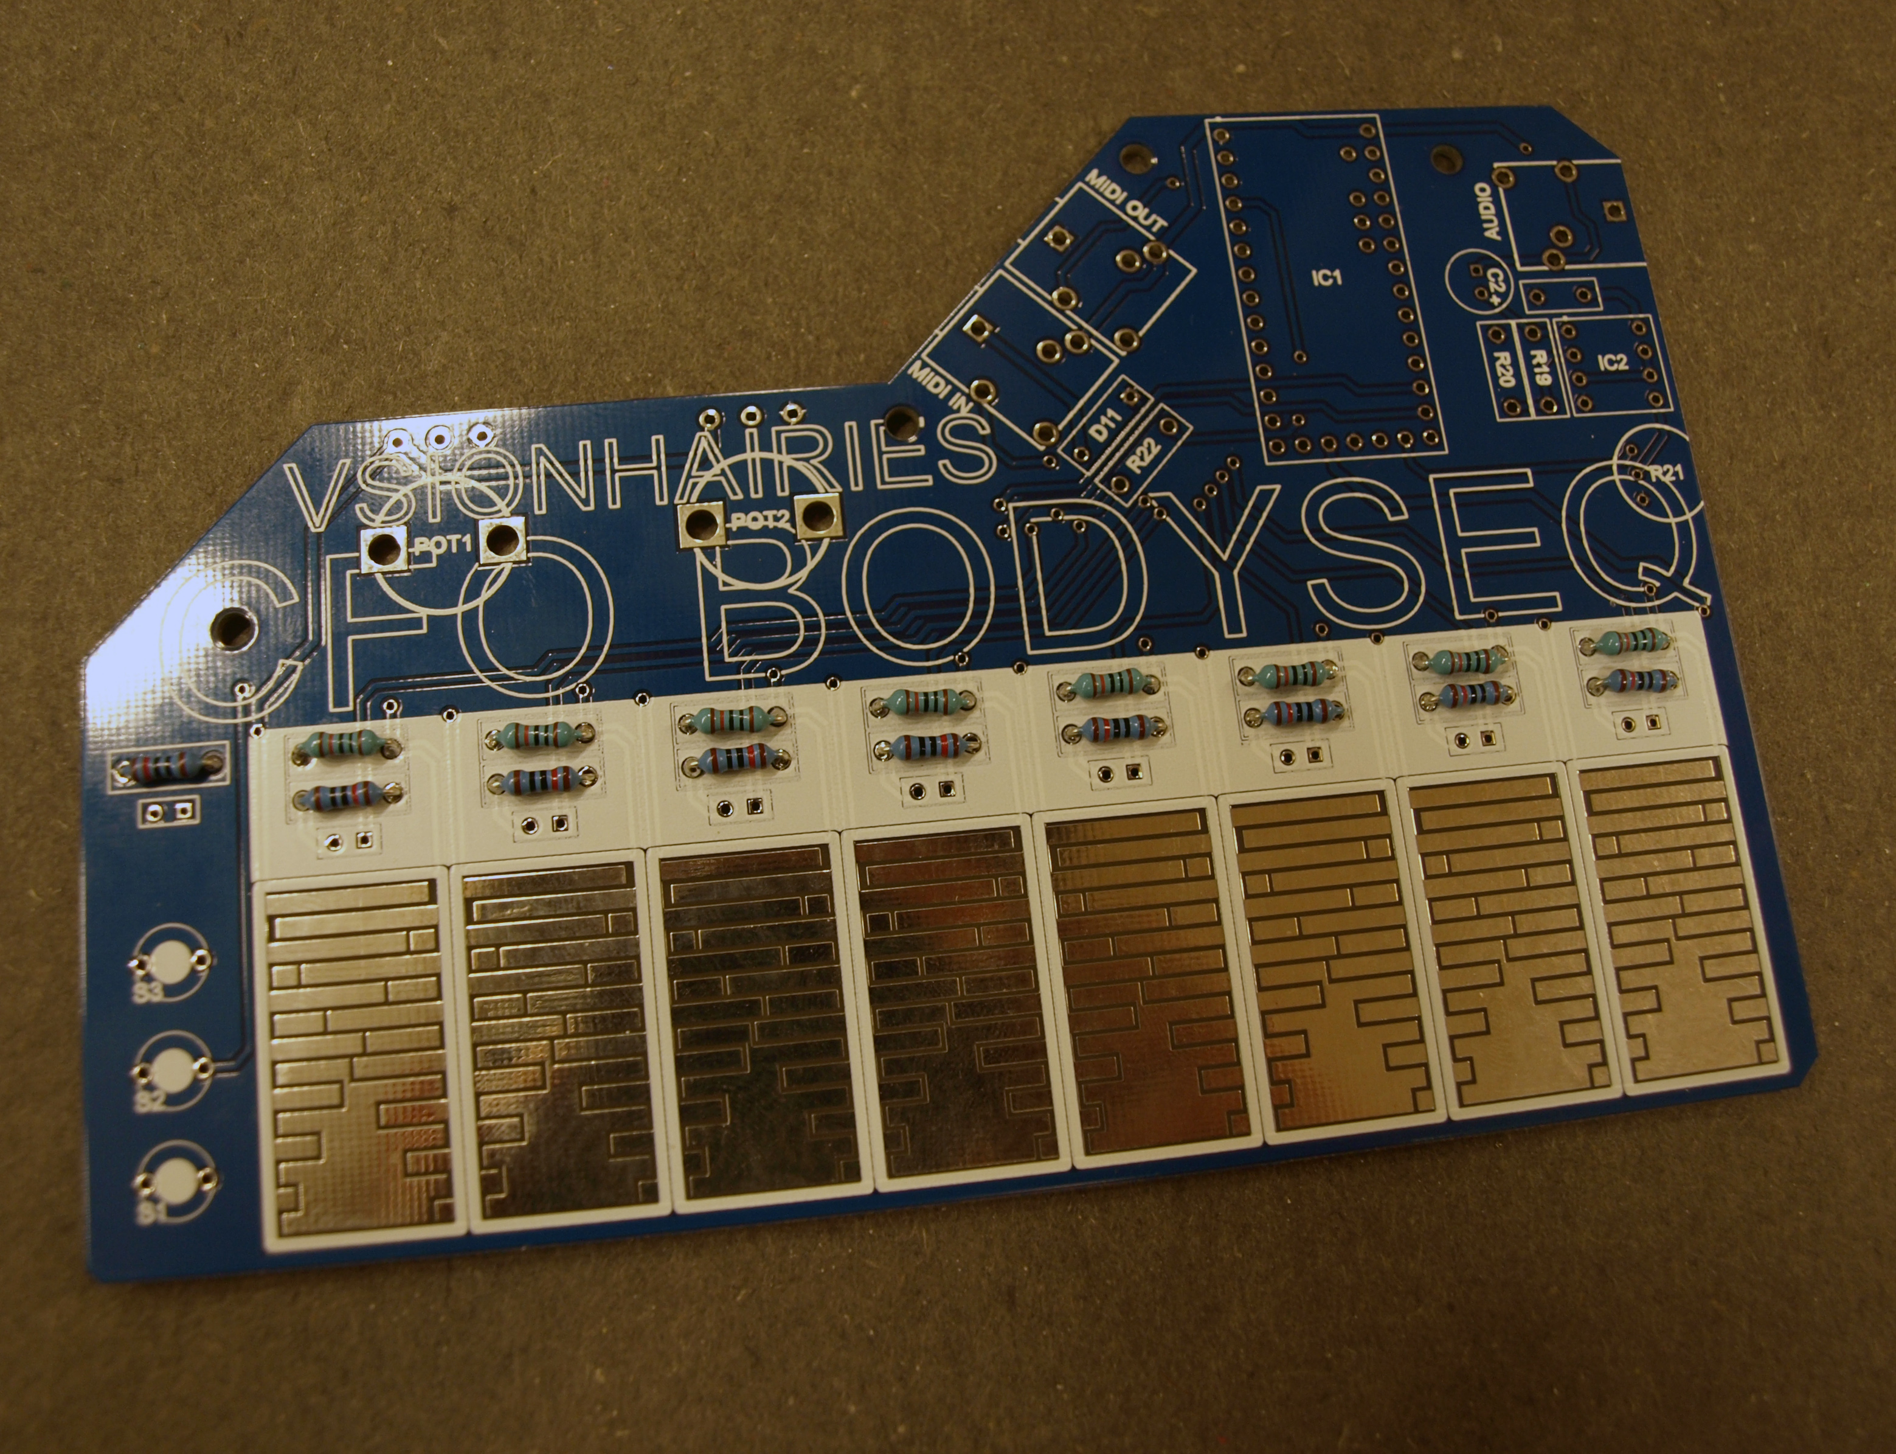

solder pull down resistors R11 - R18 (10k)

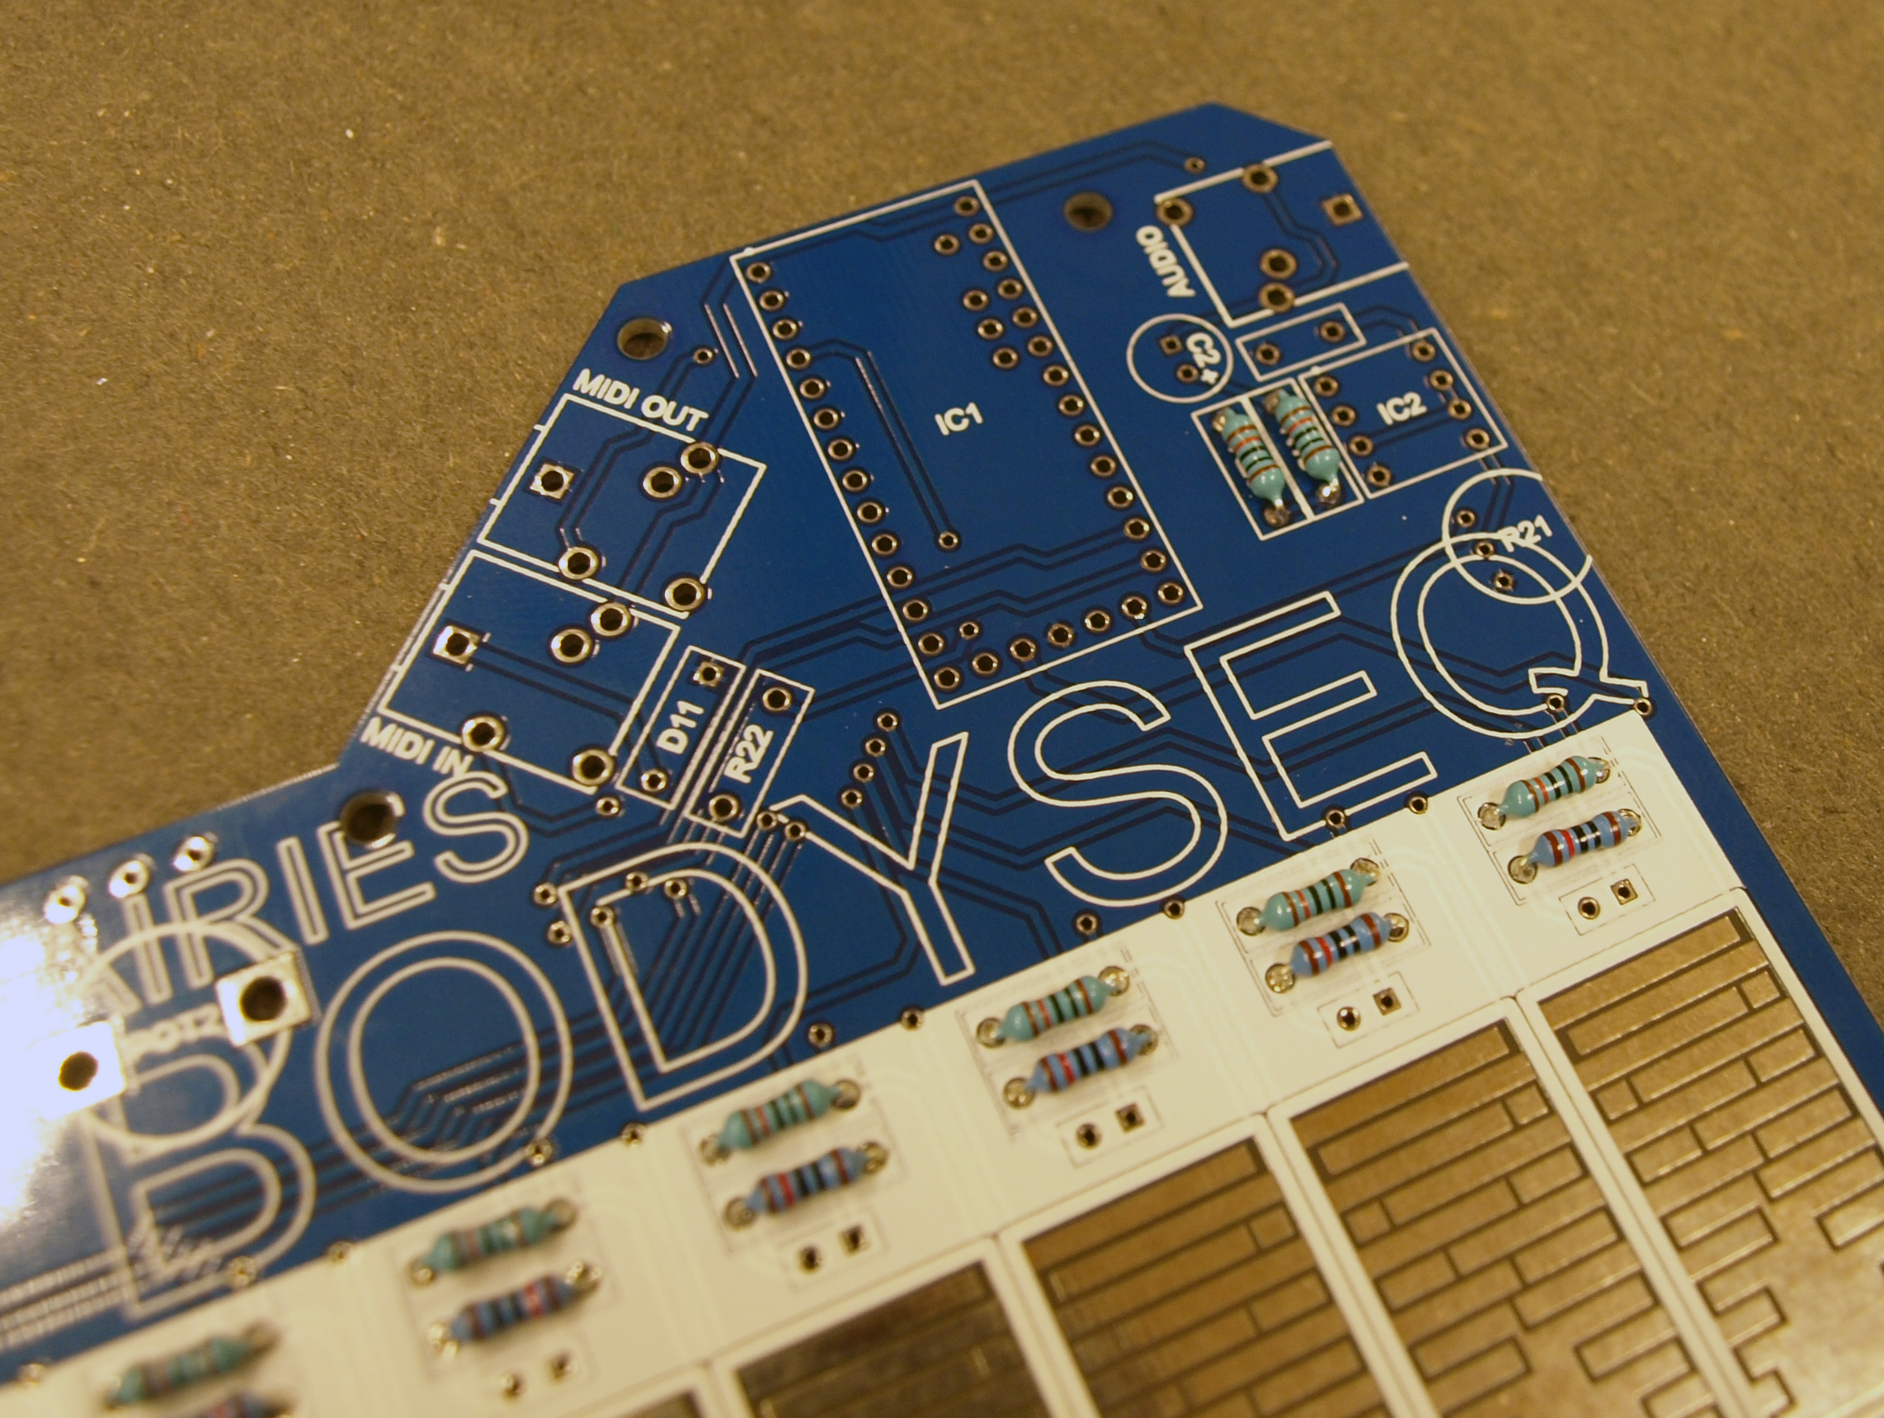

solder R19 + R20 (10k)

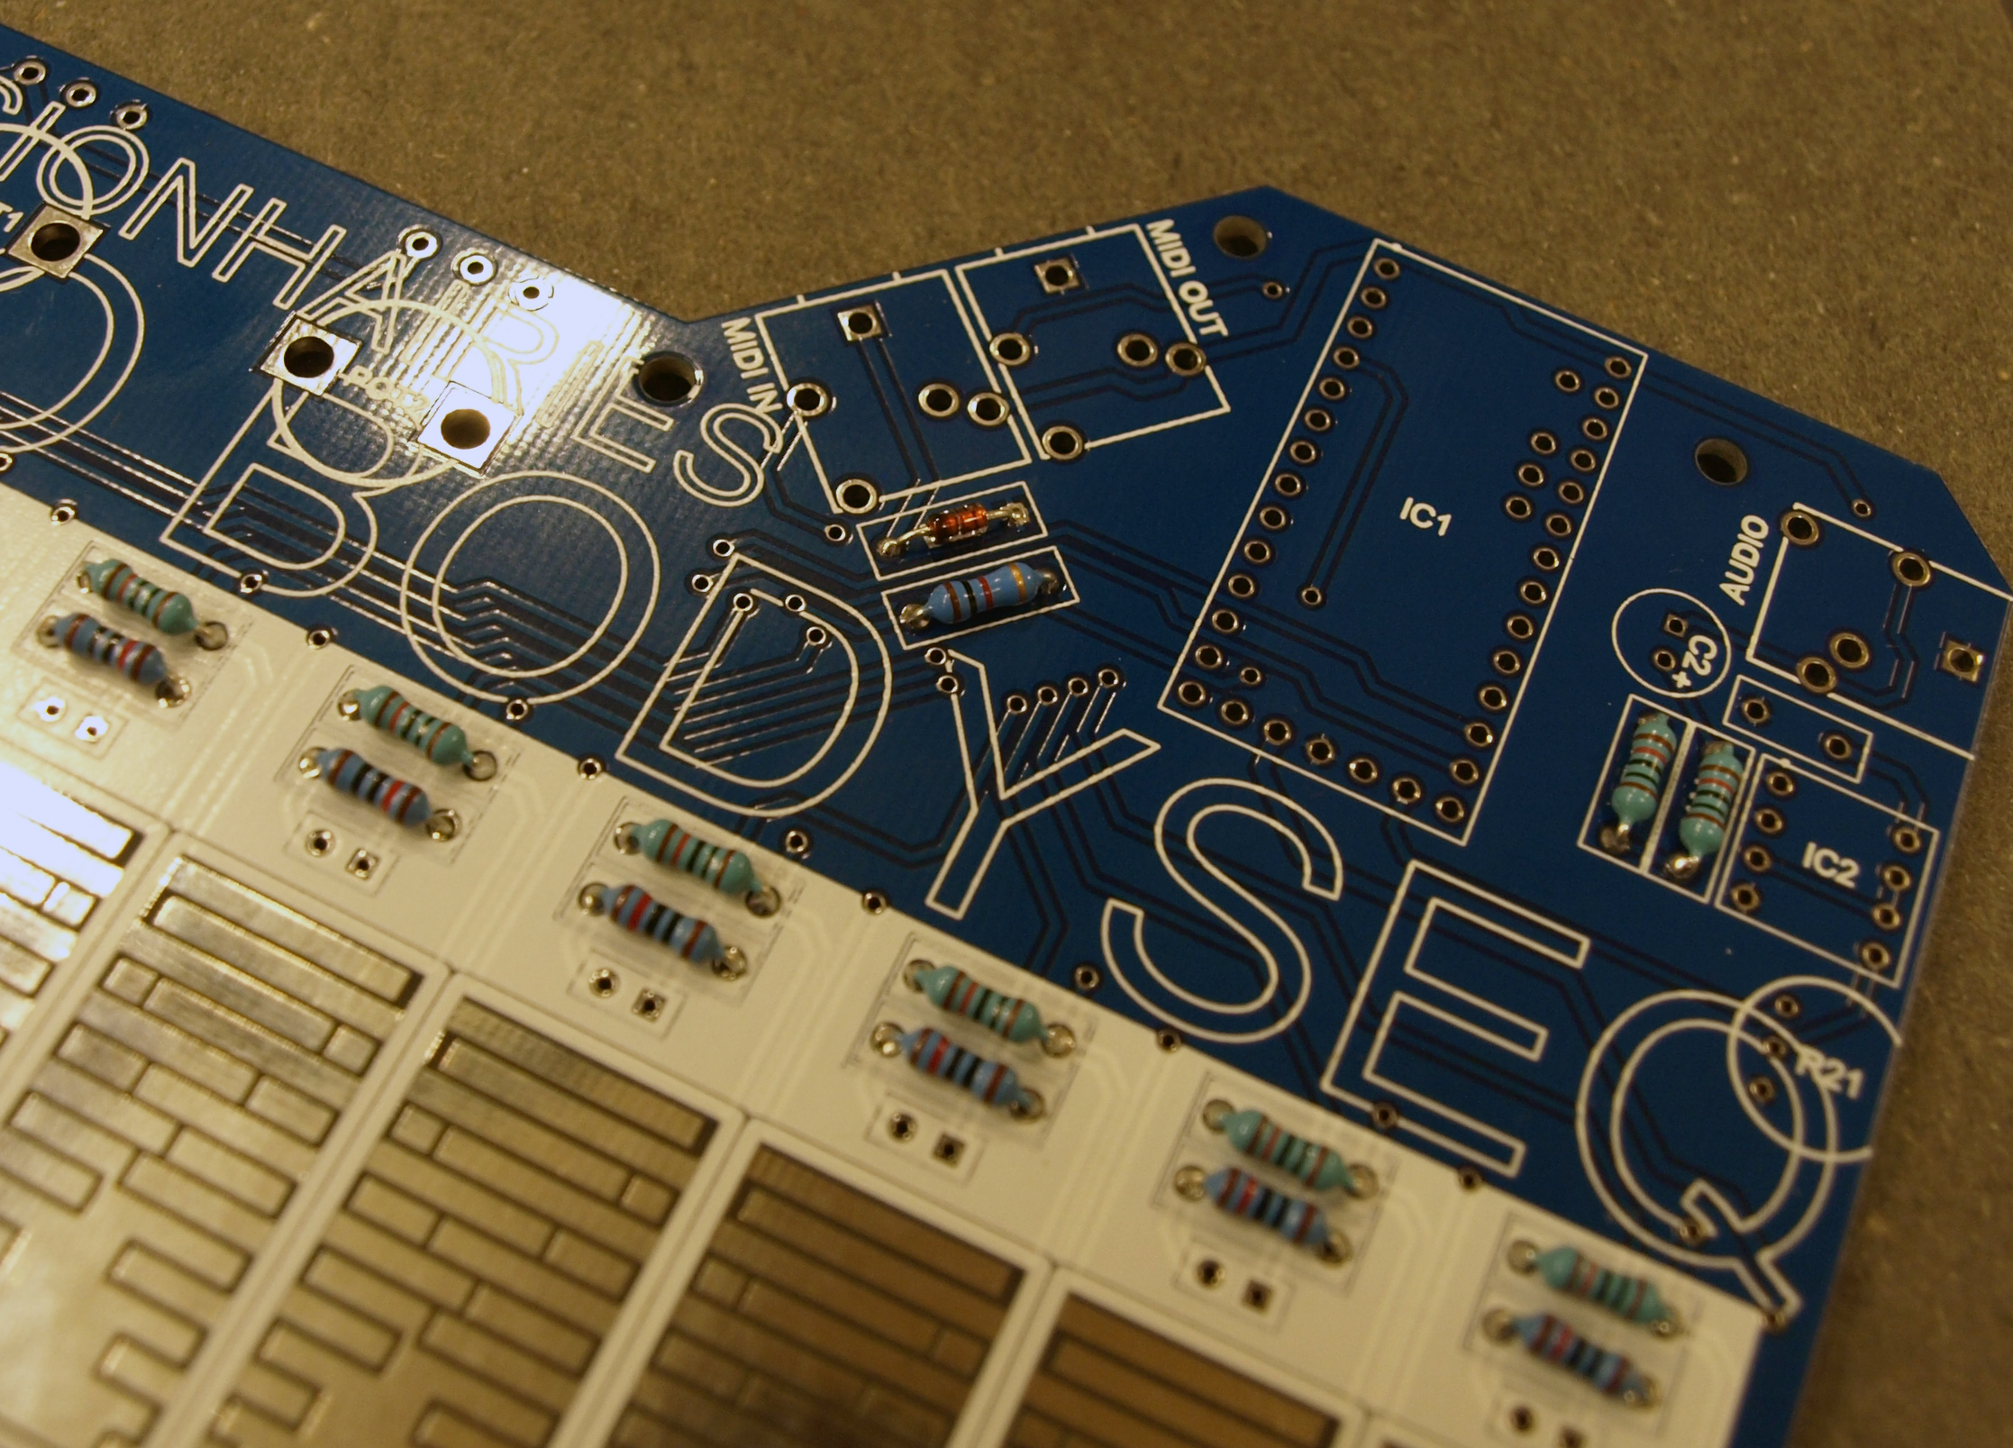

solder diode D11 (NB: make sure you have the polarity right / turn it the right way) and R22 (1k)

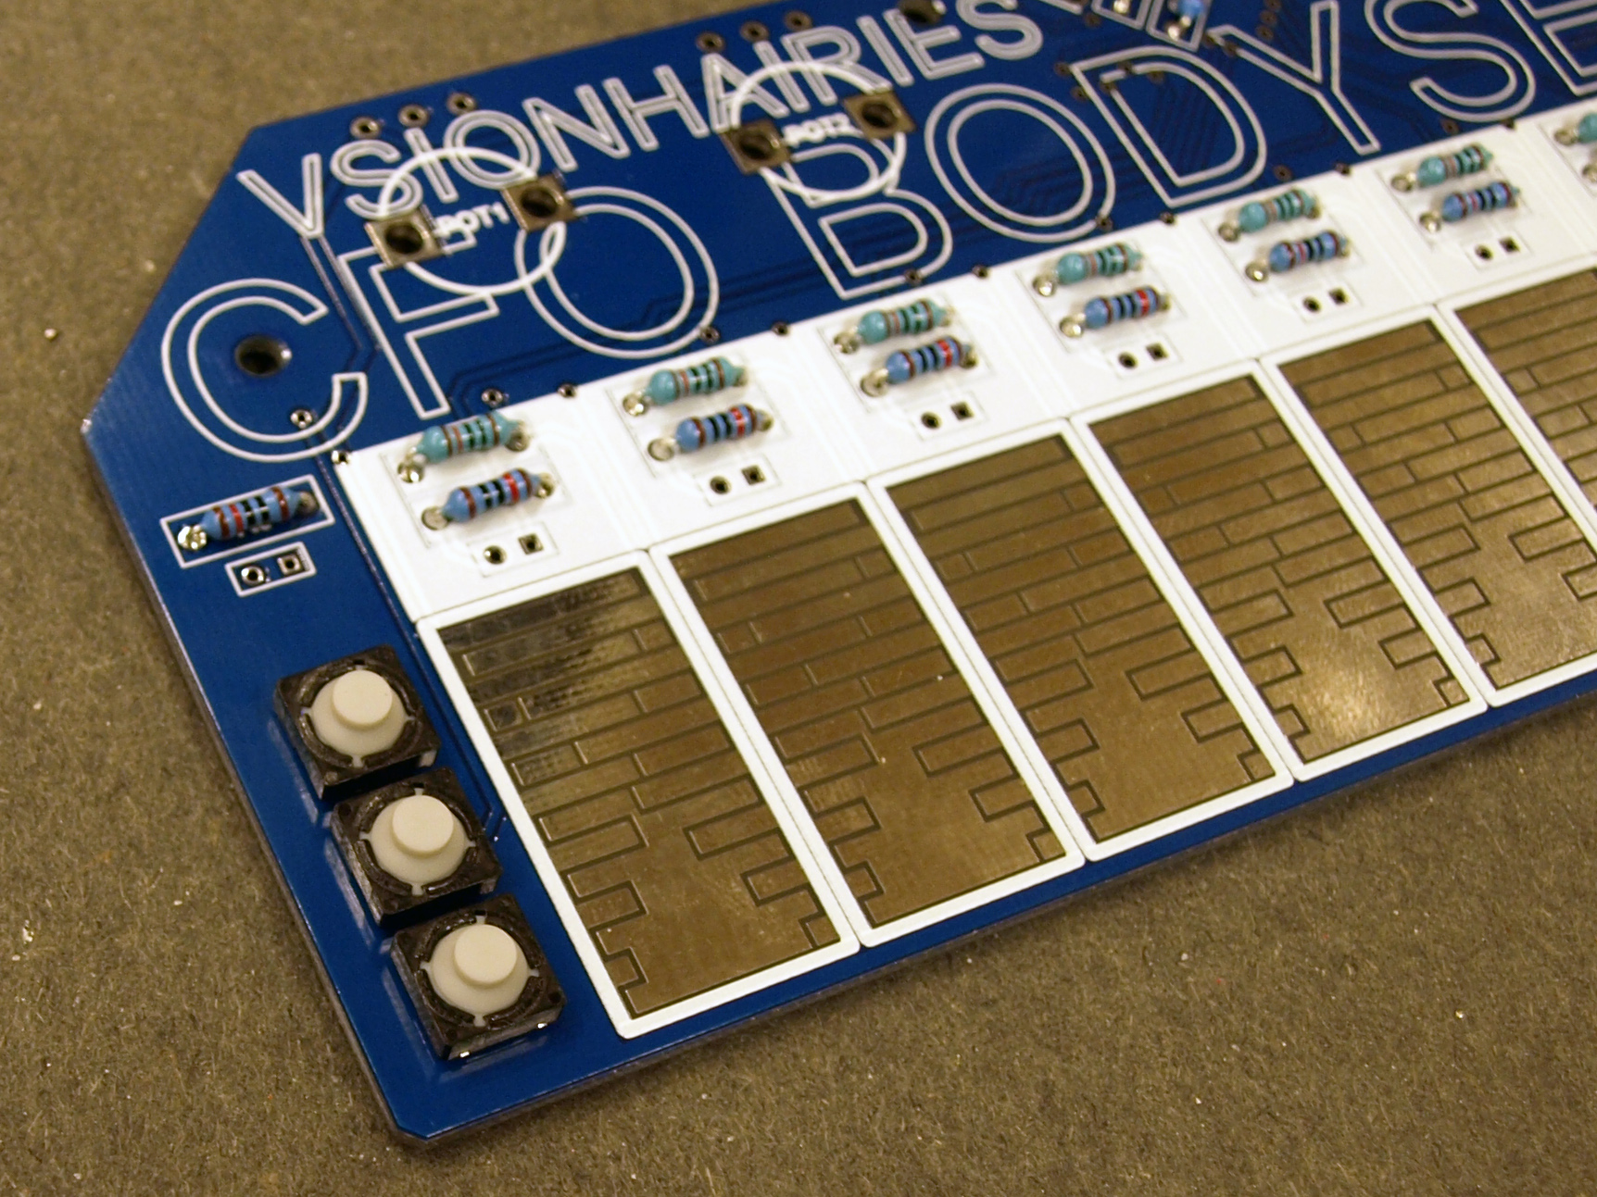

solder tactile switches S1 + S2 + S3

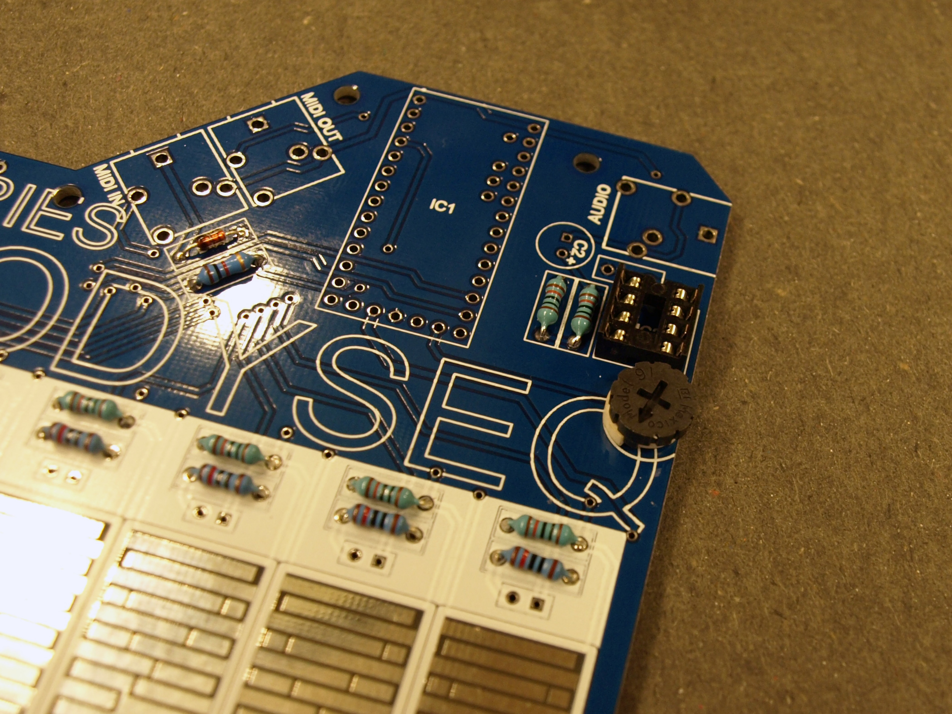

solder thumbwheel potentiometer R21 + IC socket IC2 (NB: make sure the IC socket is oriented upwards: the marker/indent should be on top)

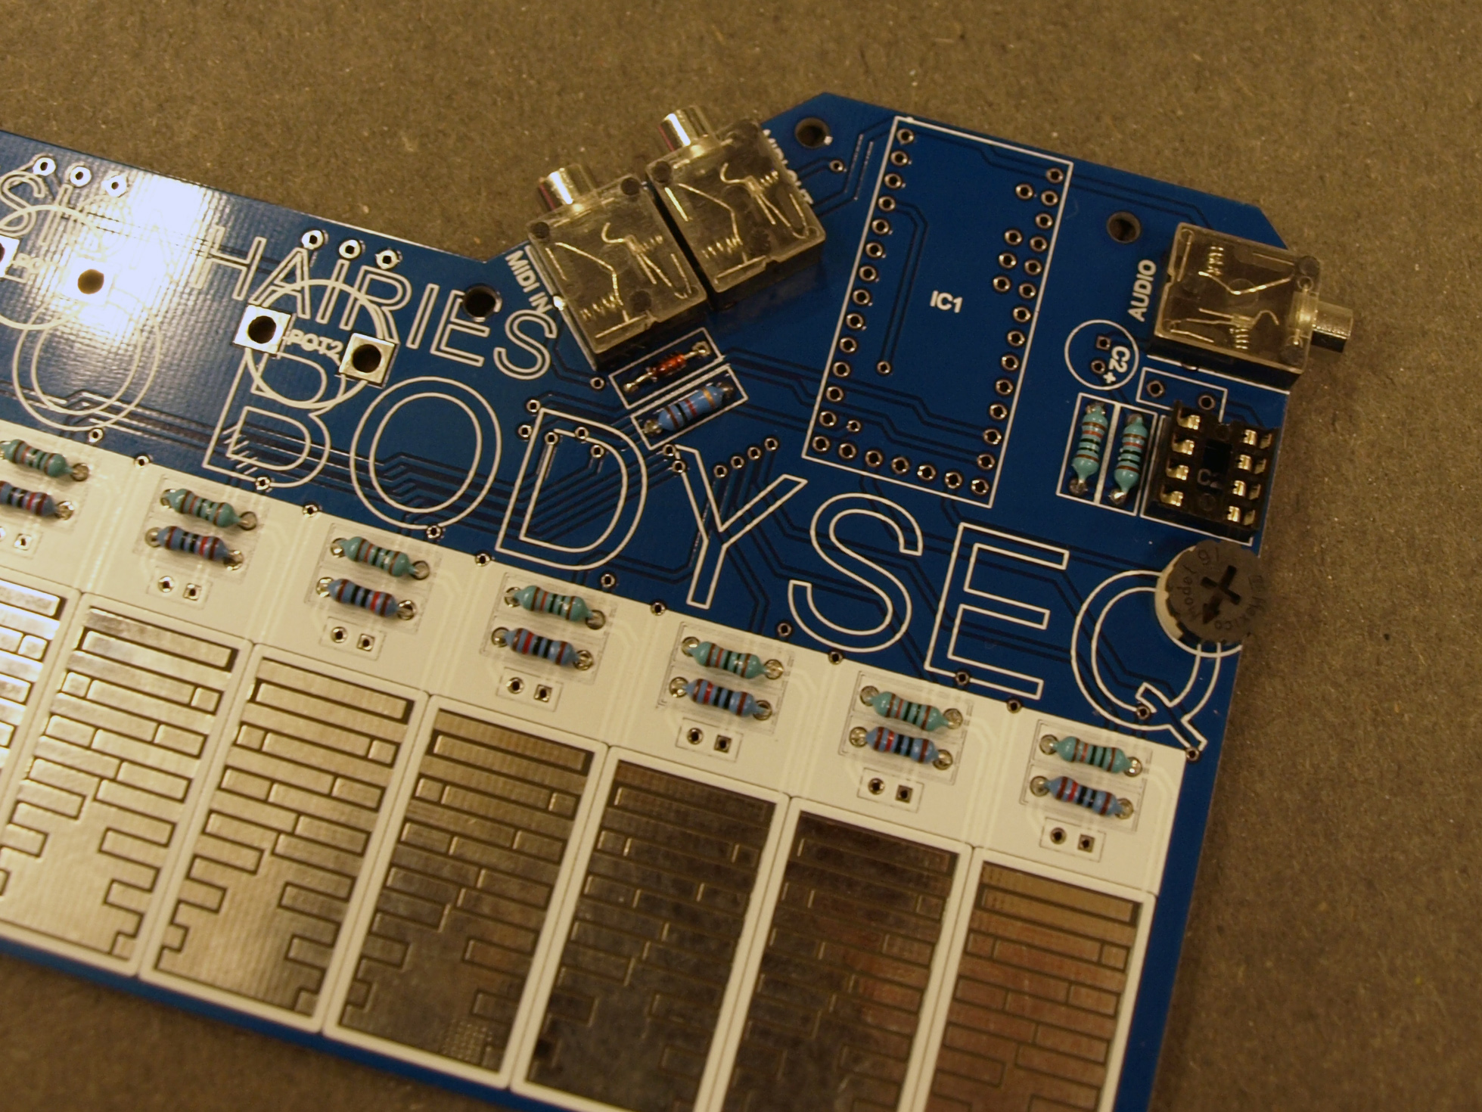

solder mini jacks AUDIO, MIDI IN, MIDI OUT

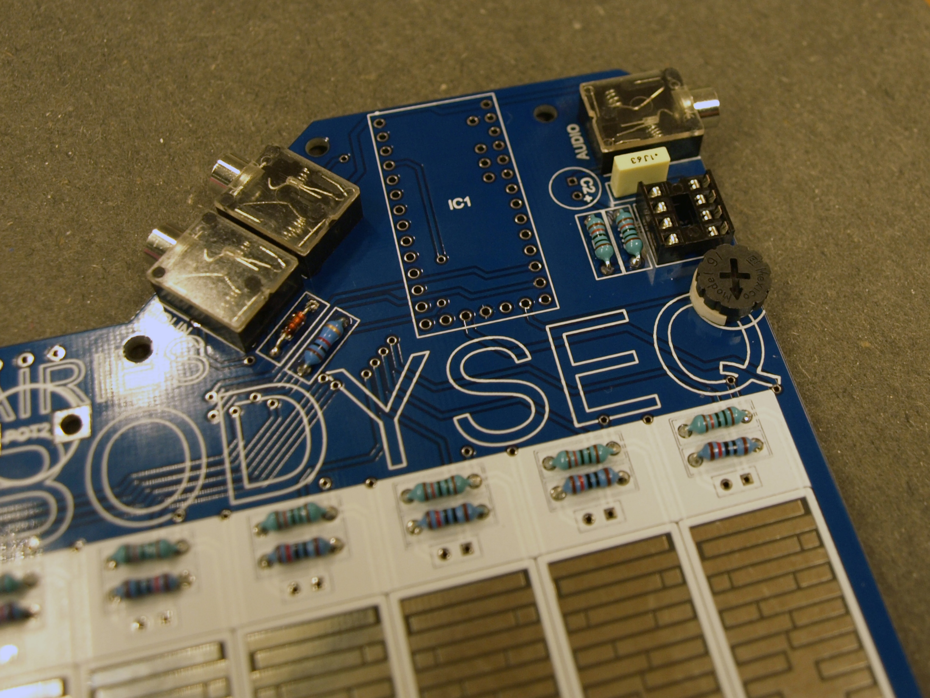

solder C1 (100 nF capacitor)

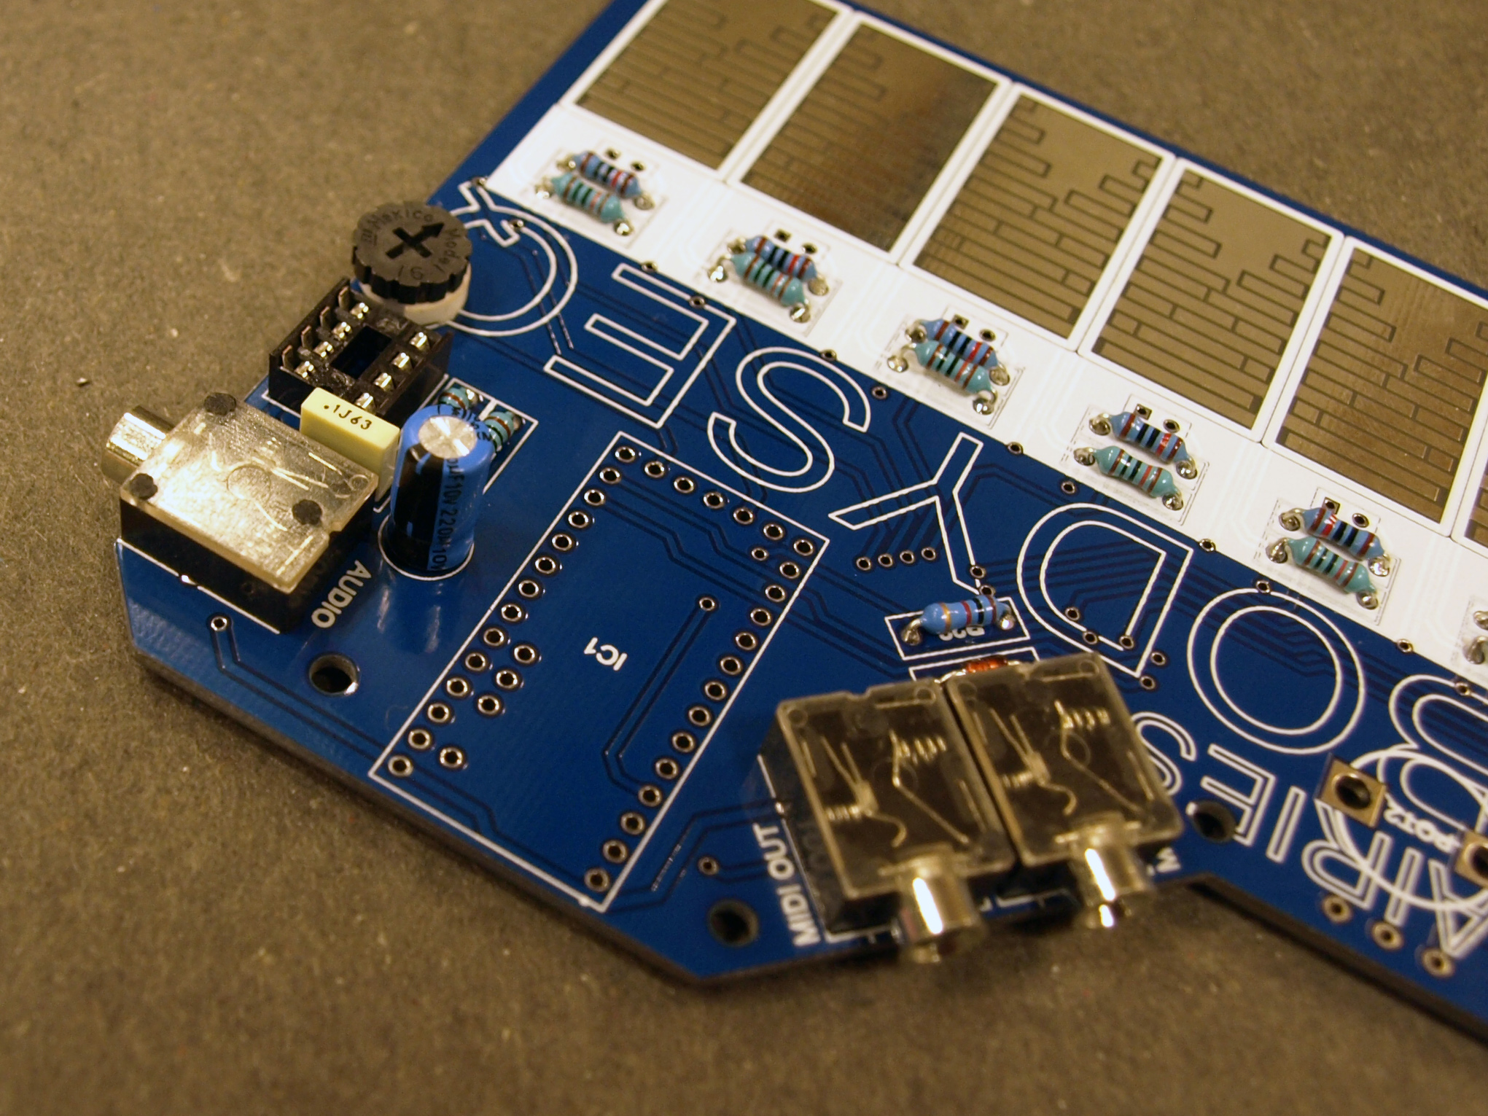

solder C2 (220 uF radial capacitor, NB: make sure you have the polarity right / turn it the right way)

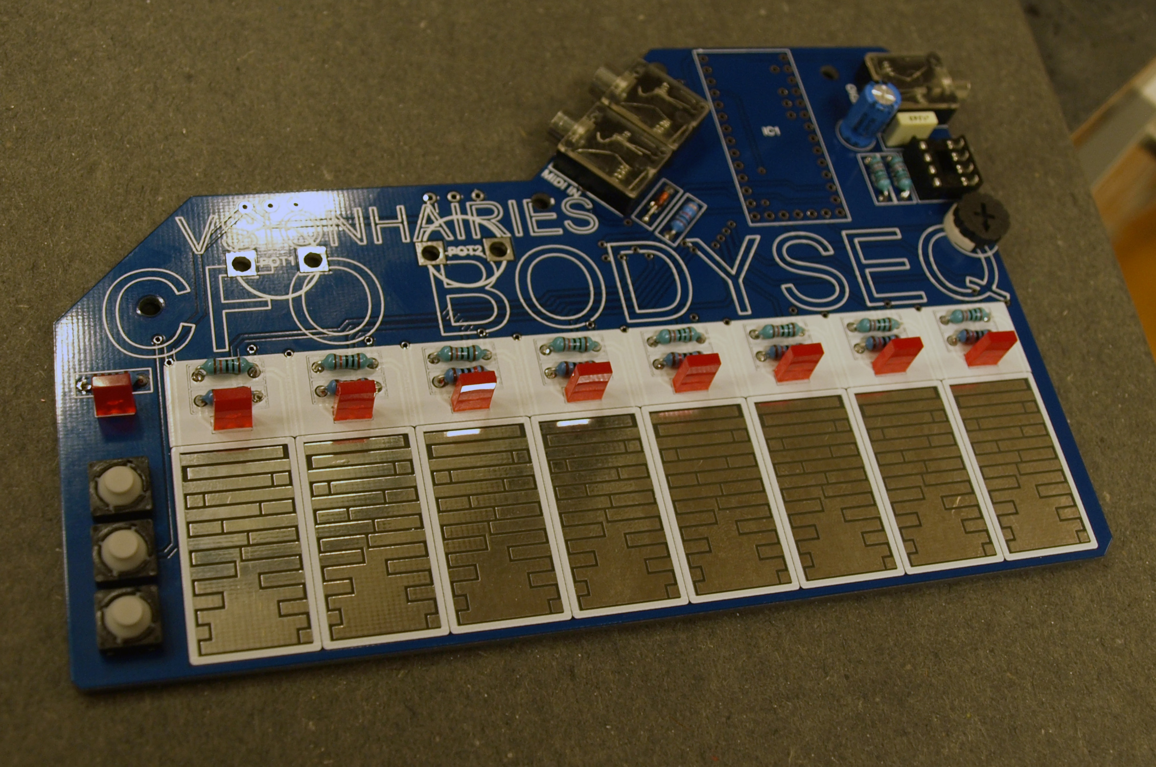

solder LEDs D1-D9 (NB: polarity: plus is RIGHT leg / square marked hole)

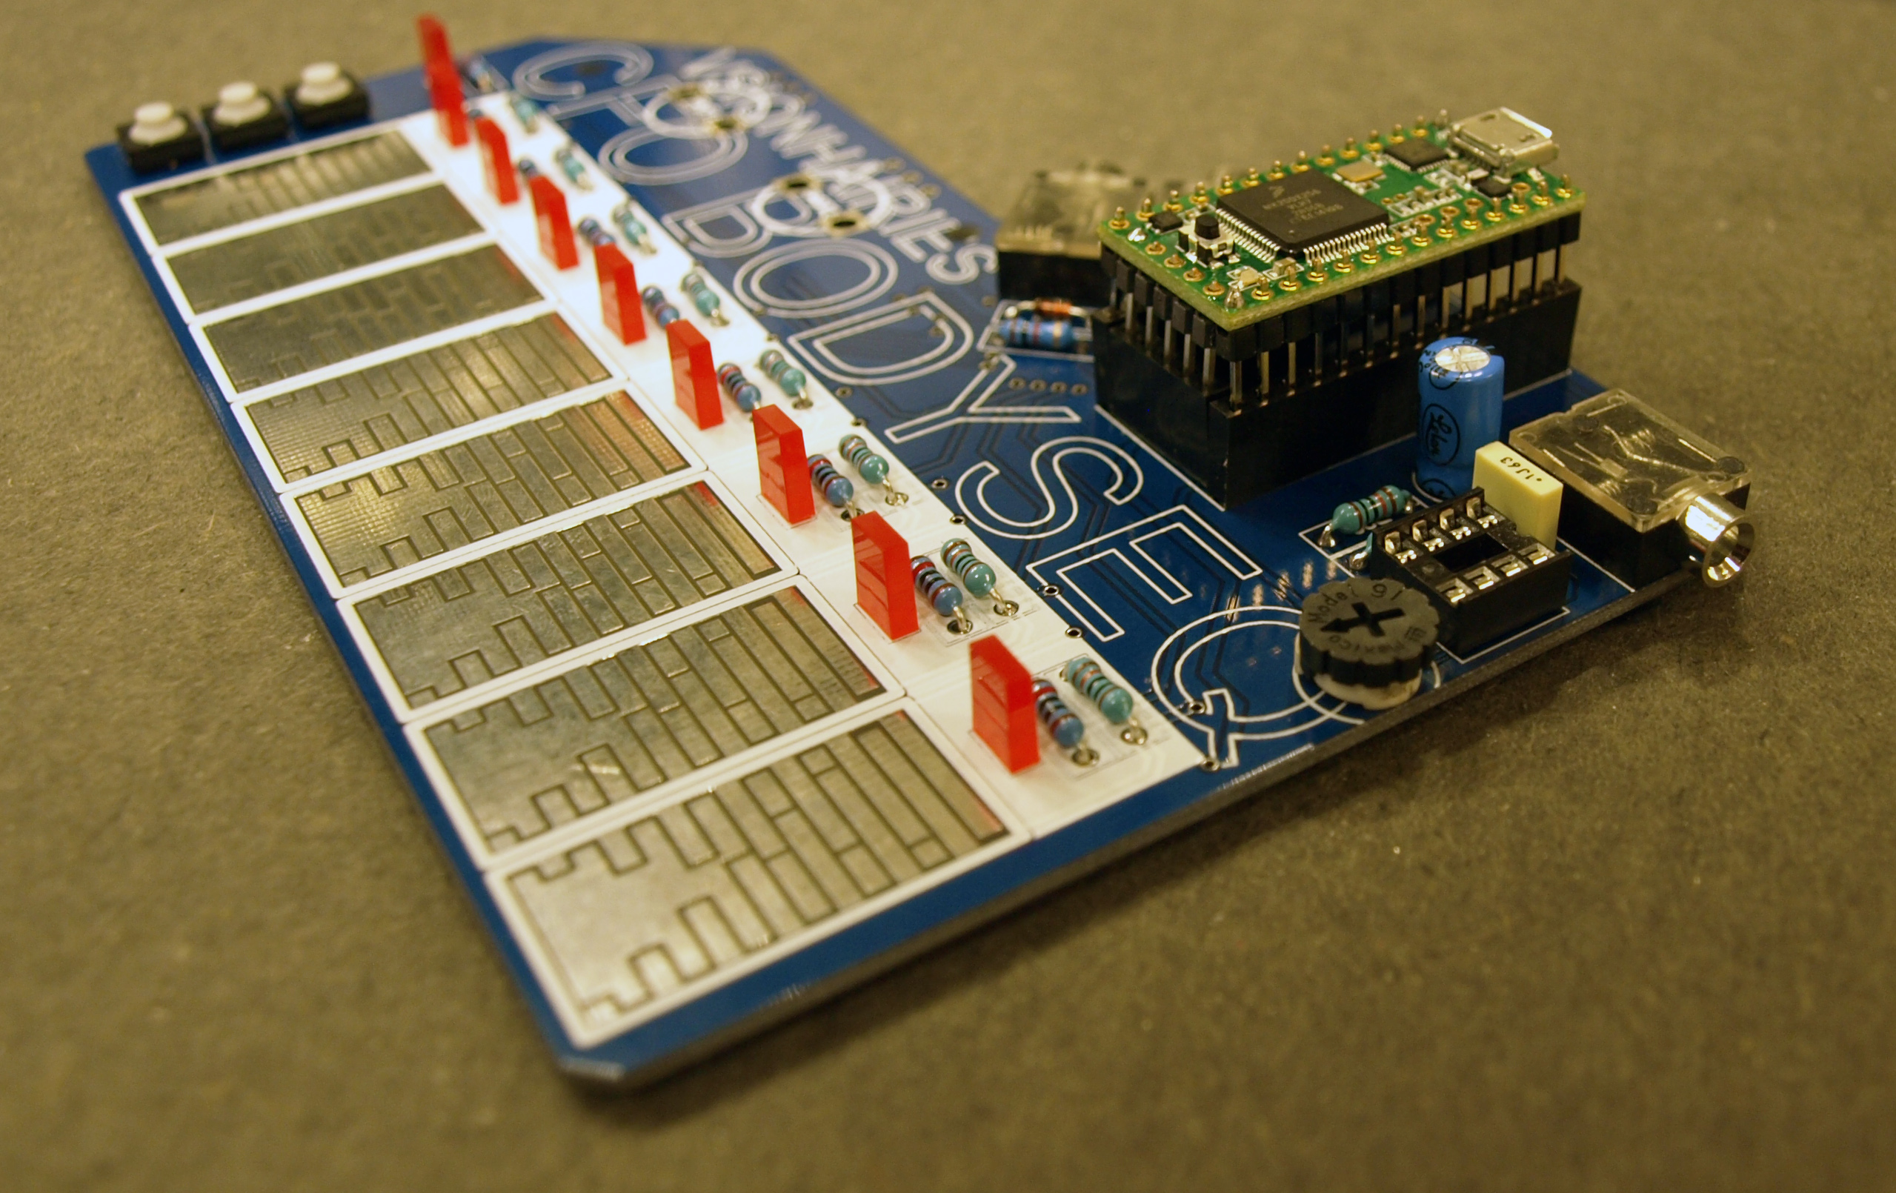

solder male pin headers to teensy 3.1 microcontroller. TIP: start by soldering only one pin on each male pin header, making sure the pins are still a bit flexible, for fitting the teensy on the female pin headers (see next step)

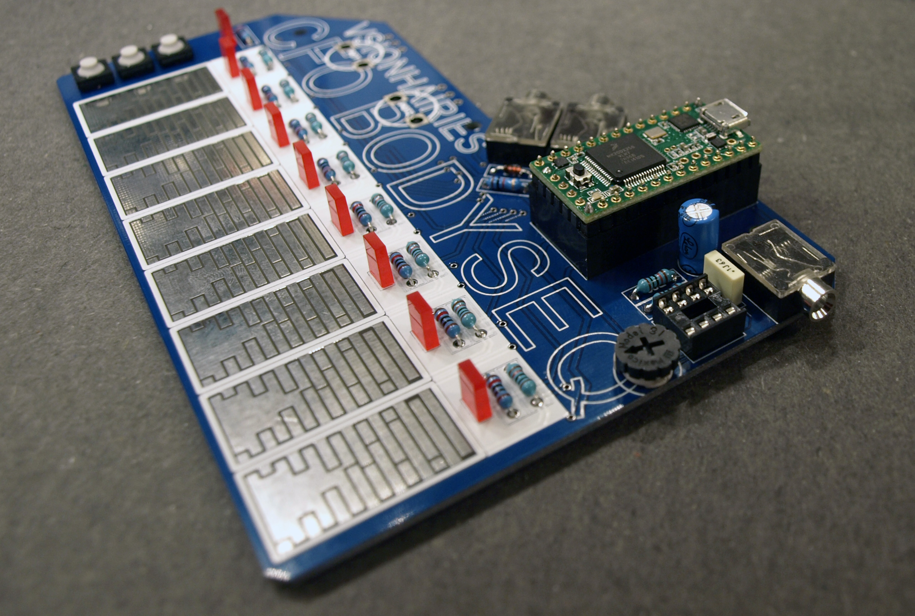

apply female pin headers on PCB and mount the teensy on top. when everything is aligned, solder the remaining pins on the male pin headers and the female pin header.

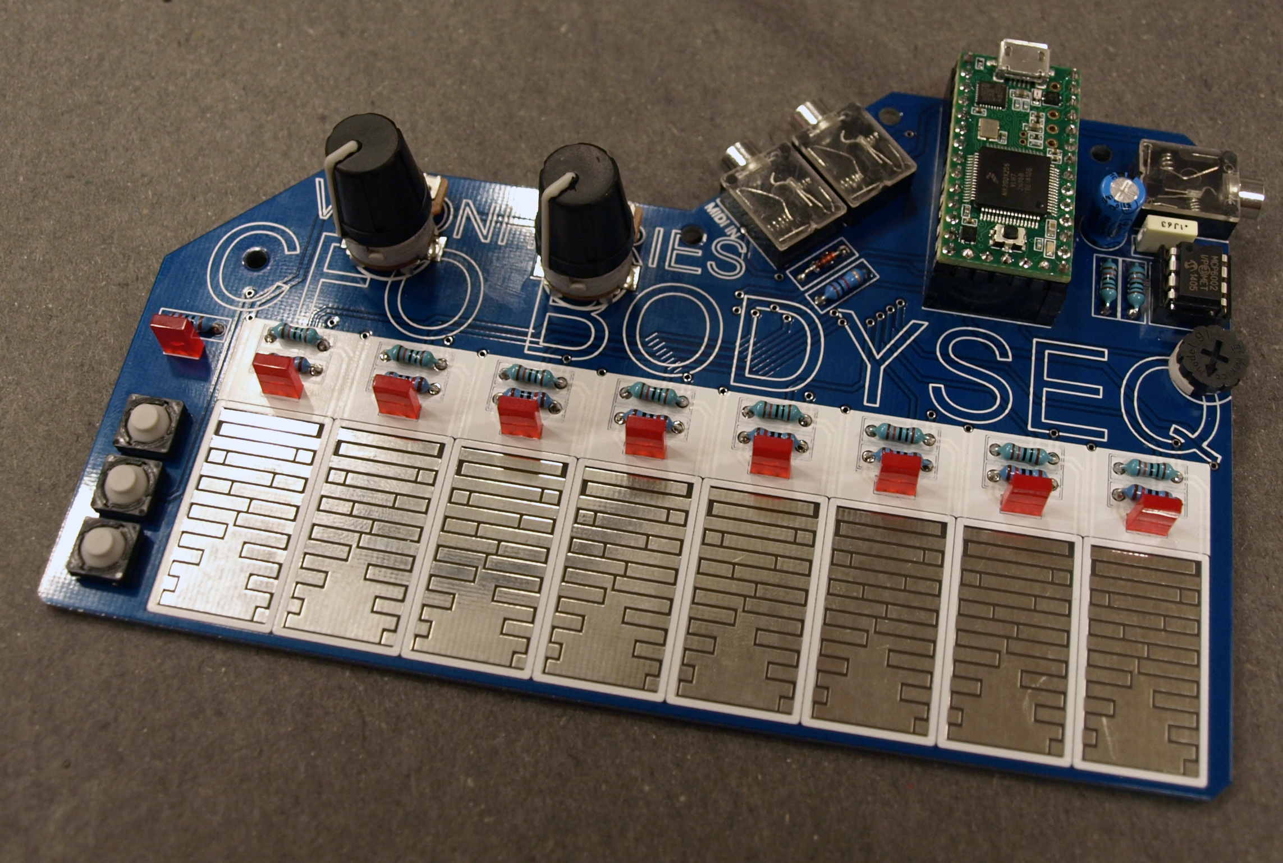

apply op amp IC (dot / marking facing upwards)

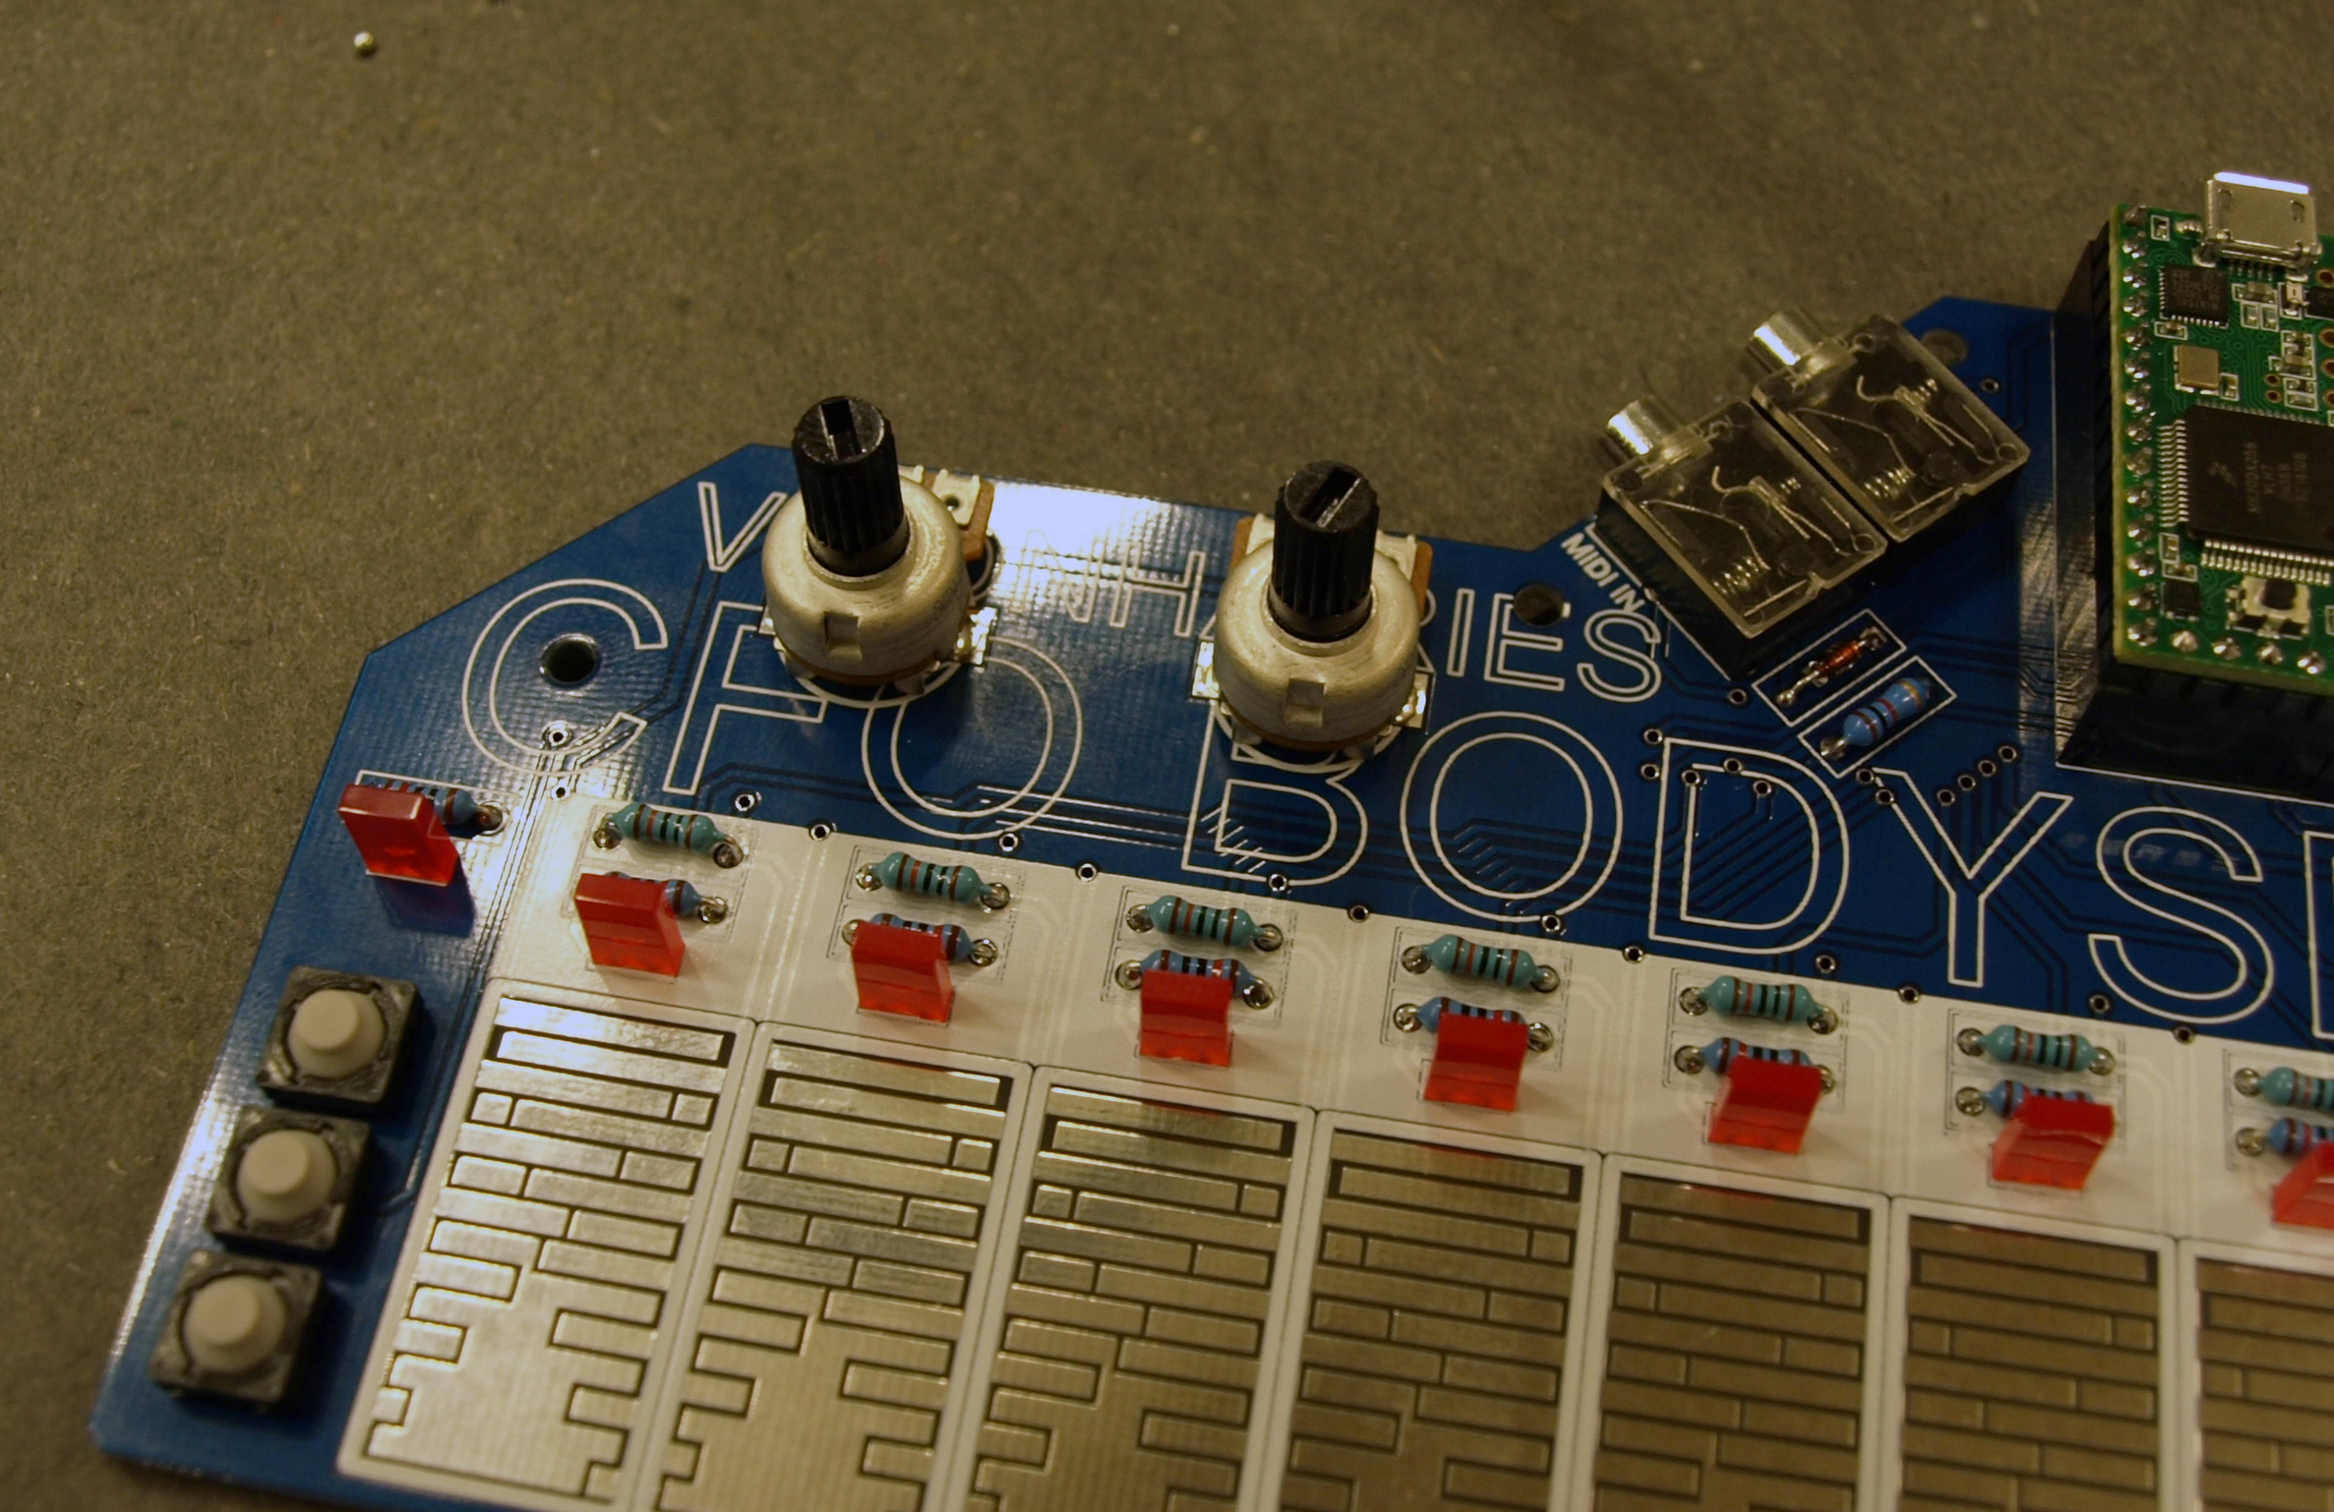

solder POT1 + POT2

turn knobs all the way to the left and attach knobs in minimum position



get dressed. its ACID TIME!